What Do Qualifications Mean? l Qualifications Vs Certifications.

Qualification and certification are vastly different. Being qualified for project management means you have the skills, experience, and temperament for the job. Therefore, qualifications for project management in this context can have an assortment of implications, depending on the organization and the position they are hoping to fill.

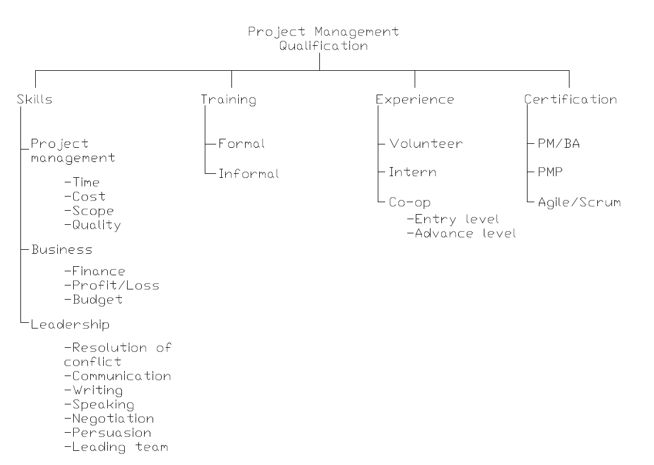

Project Management Qualifications Overview

There is basically four core qualification. They can be further broken down into their basic components.

Skills
- Project Management: In Normal conditions, one will have to start understanding their respective profession step by step, which would able them to break down the four core competencies -
- Time- as in the time it takes to complete the project.
- Cost- which involves the financial investment.
- Scope- or the work that the project requires.
- Quality- meeting the needs of the customer.
- Business: There is a business side to project management. This includes a good grasp of the project financials, an understanding of profit, loss, turnover, as well as the skill of making a budget and sticking to a project budget.
- Leadership: Leading a project inherently means being a leader. Leadership is not a technical skill, but it can be studied and taught. Some leadership skills include being able to resolve conflicts, communicating, speaking, and writing clearly, having negotiating skills, being persuasive and leading teams.

Training
There are two channels that lead to learning the skills necessary for being a project manager.
- Formal: These are structured courses of study devoted to the skill of managing a project, from getting a degree at an institution of higher learning to any number of certification programs.
- Informal: Some organizations have in-house programs to help you transition into project management or offer mentor and shadowing programs. There are also volunteer works you can do to get the experience.

Experience
Work experience is any experience that a person gains while working in a specific field or occupation, but the expression is widely used to mean a type of volunteer work that is commonly intended for young people — often students — to get a feel for professional working environments. It is one of the most valued Project management qualification.
- Volunteering: Volunteering is a way to get the experience you need. This can be through seeking projects that need guidance or leadership, or you might find such opportunities at your current place of employment.
- Internships: Look for opportunities to intern at some business or organization that is looking for people to help with managing their projects. This could lead to full-time employment, but at the very least it adds real experience to your resume.
- Co-Op: This is just another way to volunteer or intern at an organization. It usually applies to students who are seeking professional experience and consists of both formal training and learning experience.
  - Entry Level/Advanced Level: Depending on your level of experience, newcomers to the industry can seek entry-level positions, while those with some years of project management experience can look for a more advanced-level position.

Project Management certification
Project management certification is also a qualification that helps to add values to your resume Project management jobs are high in demand. So, in most cases, several people apply for these jobs. It is time and resource consuming for the company to interview and assess the potential of all the applicants. As such, they like to filter out as many people as possible before the project management interview process. This is where the Project management certification proves beneficial as it is one of the most objective ways in which one can shortlist the candidates. It also provides industry recognition. Some of these certifications are recognized globally. You can improve and learn skills. These things can contribute to increased income.

